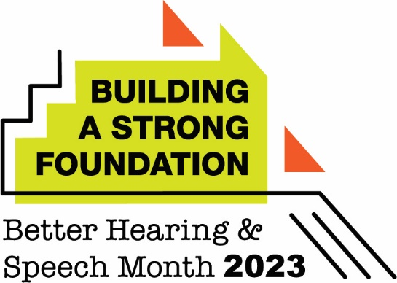

Communication and Swallowing Disorders Common Following Stroke, Other Illnesses and Injuries in Adults

(City) Residents Encouraged to Learn the Signs, Seek Help This Better Hearing and Speech Month

(City, State – May 1, 2023) With speech, language, and swallowing disorders common following stroke, head and neck cancer, and a variety of other illnesses and injuries, (city)-based speech-language pathologist (name, credentials, place of employment) encourages residents to learn the signs—and seek an evaluation—if they have concerns about themselves or a loved one. This is a timely message, as May is recognized nationally as Better Hearing and Speech Month.

“A person’s ability to communicate effectively is something that’s easy to take for granted until it’s compromised,” said (last name). “Communication enables us to connect with others. It’s needed to learn, to earn a living, and to fulfill our basic wants and needs. Given this, it is critical people know the signs of communication disorders, and the availability of help from certified speech-language pathologists.”

The causes of speech and language problems that begin for the first time in adulthood can vary. They include brain injury, stroke, and diseases that affect the brain such as Alzheimer’s disease, amyotrophic lateral sclerosis (ALS), multiple sclerosis, and Parkinson’s disease. They can also stem from cancers of the head and neck, breathing problems, and vocal cord injury.

For adults, the signs of speech and language disorders may include the following:
- problems saying sounds correctly
- slurred or slowed rate of speech
- problems coordinating mouth or speech movements
- difficulty imitating speech sounds
- struggles to get out sounds or words
- repetition of sounds, words, or parts of words
- changes in voice (e.g., hoarse, raspy, breathy, nasal, or low-volume voice)
- trouble thinking of the words they want to say
- problems expressing what they want or need
- saying words in the wrong order
- trouble following directions or conversations
- difficulty understanding what others say
- new trouble reading, writing, spelling, or using numbers

Speech-language pathologists (SLPs) evaluate adults for communication disorders in home-based care, health care facilities, and private practices. They help their patients and clients get back the skills important to them for their everyday activities.

SLPs can help people with understanding questions, directions, conversations, and stories; expressing thoughts and words; and reading and writing. They can also help people find other ways to communicate if they are having difficulty with spoken or written communication. These may include pointing or using other gestures, drawing pictures, or using an augmentative and alternative communication (AAC) device.

Some adults may develop swallowing problems from the same illnesses or injuries that can cause communication disorders. Swallowing disorders, called dysphagia, can affect a person’s ability to eat, drink, and take medicine. Dysphagia is also diagnosed and treated by SLPs. SLPs can help a person with dysphagia strengthen their muscles to chew and swallow; identify strategies that make it easier or safer to swallow; and advise people on changes to the textures of their diet, including softer foods.

Some signs of dysphagia may include trouble moving food from the mouth to the throat, coughing during or right after eating or drinking, feeling like food is stuck in the throat, and pain or discomfort during eating or drinking.

“It’s important to remember that eating and drinking are not only necessary for us to live but also are often at the center of our social gatherings,” said (last name). “Swallowing problems can improve tremendously with treatment from SLPs.”

(City) residents who would like to schedule an assessment for a communication or swallowing disorder may contact (last name) at (phone, website). More information is available at www.asha.org/public.

###

